Experiment 6
Write a program to implement Naïve Bayes algorithm in python and to display the results using confusion matrix and accuracy.

Aim
To implement the Naïve Bayes algorithm in Python and evaluate the model using a confusion matrix and accuracy score.

Program
from sklearn.datasets import load_iris
from sklearn.model_selection import train_test_split
from sklearn.naive_bayes import GaussianNB
from sklearn.metrics import confusion_matrix, accuracy_score
# Load dataset
data = load_iris()
X = data.data
y = data.target
# Split dataset into training and testing
X_train, X_test, y_train, y_test = train_test_split(X, y, test_size=0.3)
# Create Naive Bayes model
model = GaussianNB()
# Train the model
model.fit(X_train, y_train)
# Predict test data
y_pred = model.predict(X_test)

# Confusion matrix
cm = confusion_matrix(y_test, y_pred)
print("Confusion Matrix:\n", cm)

# Accuracy
accuracy = accuracy_score(y_test, y_pred)
print("Accuracy:", accuracy)

Output

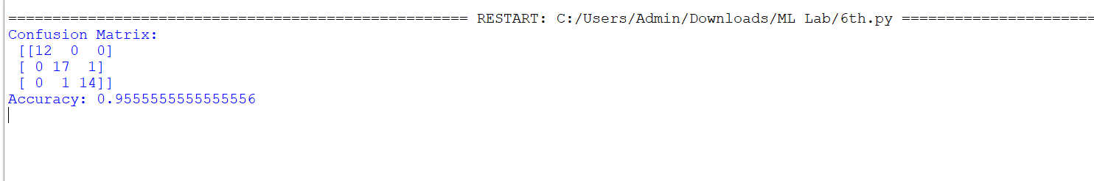
Result
The Naïve Bayes algorithm was successfully implemented in Python, and the model performance was evaluated using the confusion matrix and accuracy score.

